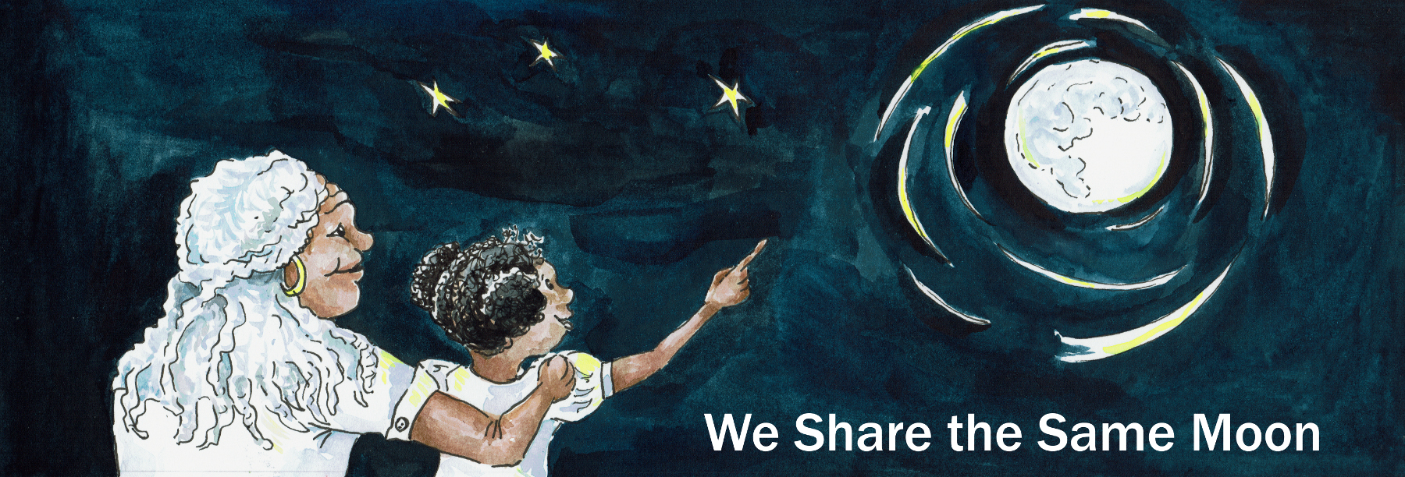
Suggested Age Range: 10 - 11 years; 11 - 12 years; 12 - 13 years; 13 - 14 years; Adult
UK Curriculum: Key Stage Two
Suggested UK Year Group: Year Five
UK Primary Curriculum Link: Earth and Space
Science Subject: Stars, Constellations and Clusters
Science Questions: What are constellations? What are Stars? What are Clusters?
Suggested Science Activity: Constellations
Children with SEND: Use to boost comprehension of science vocabulary
EAL children: For intermediate learners
Country of Origin: Sweden
Source: The Magic Pisspot: Swedish folk tales by Per Gustavsson, trans. R. Martin

There was once a land, ruled by a King, who had, but the one child, a daughter, who he brought up to rule after him. Now, this young woman was as wise as she was beautiful, and she was as beautiful as the Dawn. And she loved more than anything, to sit in the gardens of her father's castle with all her maids and while away a summers afternoon in the welcoming shade of an old beach tree. And this they did, for day after day, week after week, month after month as rumours of her beauty spread throughout her father’s land.

And so, one afternoon, whilst the Princess and her maids sat under their favourite tree, the air all around them grew strange. The sky changed from blue to yellow, and a storm cloud grew. Thunder broke the sky and lightening crashed down. And their was a crack as the tree broke under the storm. The maids ran for shelter, back to the safely of the castle, behind the iron doors.
But, when the doors slammed shut behind them, they realised in their fear and confusion, they had left the Princess behind them. And the Princess had gone.
Where could she be?

The sky was filled with lightening. It was not safe to go out. Nevertheless.
The soldiers poured out of the castle doors, scouring the grounds for any sign of the Princess. But there was none.
Where could she be?

As the storm lifted, and the sky emptied of cloud and the sun shone, there was silence. Where the Princess and her friends had filled the air with shouts of joy and laughter, there was now no sound. The people of the castle were distraught by their loss.
And as for her father, the King? He did all that he could to find her. He sent soldiers to all four corners of the land, and back they came, with no sign.

Except, one young man who returned from the far, far North and said:
“I heard of a land, to the far North of our land. It was said that to get to this land, you must cross the sea of storms. And then you will reach a tiny island. And on the island there is a mountain of glass, and at the top of the mountain there is a castle. And in the castle, there lives a giant. And it was said, that the giant has captured a Princess to be his bride.”

“Then she must be rescued!” said the King. But how?
No-one could sail safely through the sea of storms.
No-one could climb a Mountain of Glass.
Who would be bravo enough to fight a Giant and bring the Princess home? No-one.
“But there must be some-one” thought the King. And so he offered a reward, the hand of his daughter in marriage to the one who would save her.

And the news travelled throughout the land.
And came to a cottage, where there lived a woman, a widow with six sons. No ordinary sons, but sextuplets, six babies born together.
And whatever these young men did, they did together.
And she said to her sons: “No-one will be able to rescue the Princess on his own”
“But together if you work as one, perhaps you will succeed.“

And so for a year and a day, for the first time in their lives, the brothers parted.
Each of the brothers set out on their own, to gain the skills needed to save the Princess.
The first brother - apprenticed himself to a Master-Sailor, and learnt to steer a ship through any storm.
The second brother - apprenticed himself to a Master-Builder, and learnt how to build a ship strong enough to sail intact through any storm.
The third brother - apprenticed himself to a Master-Climber and learnt to climb any height no matter how slippery and steep.
And the fourth brother - apprenticed himself to a Master-Thief, for he knew that to rescue the Princess, he would have to steal her.
The fifth brother - apprenticed himself to a Master-Magician and learnt to cast a spell that would throw a mist around anyone or anything to protect it from harm.
The sixth brother - apprenticed himself to a Master-Hunter and learnt to shoot an arrow to hit any target at any distance.

And after a year and a day, they came back together and set sail in the ship the second son had built.
And through the sea of storms they sailed. And no matter how fierce the storm, how high the waves, no matter how powerful the wind, the ship sailed on, steered by the first brother towards an island, on which they could see a castle at the top of a mountain.
And as they came into harbour, the storm cleared and the sun shone and sparkled off the sides of the mountain, for the mountain was truly made of glass.
“Now it is my turn” said the third brother, the climber.
“And you will need me”, said the fourth brother, the thief.
The thief climbed onto the back of his brother and when they reached the top of the Mountain; “Wait there!” he said. And on silent feet, he crept towards the Castle.
Outside the Castle, he saw the Giant, asleep with his head in the lap of the Princess. And she looked up at the thief and smiled in relief.
The thief, slid his hand under the Giants head, and he took the Princess in his other hand and softly, slowly he pulled her out from under the Giant and as gently as thistledown, he laid the Giant’s head down upon the ground.
He grabbed her and they ran!
But the Princess was not as quiet as the thief and the Giant began to stir…
“Quick!” panted the thief to his brother. “Take us all down. As fast as you can. He is starting to wake.”
The brother pulled them both onto his back and staggered a little under their combined weight, began to climb down.
Back to the ship, they ran, as fast as they could, hand in hand.
But the Giant sat up and looked around and realised the Princess had gone!
He stood up and looked and saw a ship sailing away.
The Giant roared and with one step, climbed down the cliff and with another step into the sea!
The fourth brother remembered his spell and cast a mist to hide the ship from view.
They were safe! Until, the Giant with just three steps, strode through the mist and reached out towards the ship with one giant hand!
And then with shaking hands the last brother, drew his bow and arrow and shot the Giant! The Giant crashed into ground and slowly sank under the waves.
The ship landed and together they walked back to the castle, and the King and all his court came out to greet them. And they were so happy to see them!

But, then the King asked:
“Which of you was responsible for rescuing my daughter?”
“Which of you will marry her in return?”

“I am and I will!” said the first brother, “For I built the ship that rescued her!”
“I am and I will!” said the the second brother, “For I steered the ship to safely through the storm to rescue her.”
“I am and I will!!”said the third brother, “For I climbed the mountain of glass to fetch the Princess and bring her home.”
“I am and I will!” said the for fourth brother, “For I stole her from the Giant to keep her safe from harm.”
"I am and I will!” said the fifth brother, “For I cast a spell to save her from being recaptured by the Giant!”
“I am and I will!” said the sixth brother, “For I fired the arrow, that killed the Giant and saved us all.”

And so for the first time in their lives, the brothers began to argue.
All of them wanted to marry the Princess. But only one of them could.
And which would it be?
Their voices grew loud and angry. It looked as if they would begin to fight.
The King looked on in sadness. What had he done wrong?

But the Princess. What did she do?
The Princess, she was as wise as she was beautiful and she was as beautiful as the Dawn.
And she looked at the brothers in turn.
“Am I to be an object to be fought and squabbled over like a bone?’

And she disappeared.
And once again - no-one had seen her go or knew where she was gone.

The sun began to set and the sky began to darkness.
It was the night of the New Moon, and the stars shone bright. And then…
“I see her!” cried all of the brothers at once!
For there she was, shining bright. A new star in the sky.

And then brothers turned and looked at one another, and holding hands they jumped …
Into the sky and they too were gone.
And then the watchers on the ground saw six stars in the sky appear and join the one.
And there they stay. Together forever in the sky.

And there are many, many names for those seven stars. But most sailors call them the Pleiades and they honour them, for together these seven stars shine like a beacon, to guide sailors safely home.

